Year 11 General Human Biology
Work Booklet
Circulatory System

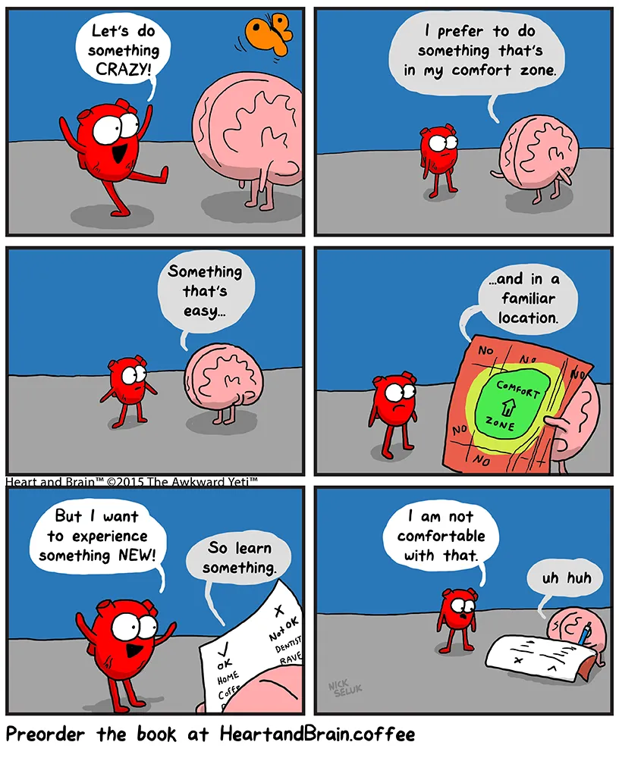

Note: You will need the notes from the Circulatory System PPT to complete this booklet. The PPT can be found on Connect or Ms McCaig has a master copy.
Answer these questions using full sentence responses. I have attached marks to each question to allow you to gauge how long your response needs to be.

- What is the name of the structure responsible for gas exchange in the respiratory system? (1 mark)
- What process occurs across the membrane of the alveoli? (1 mark)
- Discuss the four adaptations of the alveoli to facilitate efficient gas exchange. (4 marks)
- What is the equation for cellular respiration? (1 mark)
- Is there a higher or lower concentration of carbon dioxide in the blood stream compared to the alveoli? Why? (3 marks)
- Blood is made up of two structures. What are they? (2 marks)
- List three formed elements of blood. (3 marks)
- In what two forms does oxygen travel in the blood? (2 marks)
- In what three forms does carbon dioxide travel in the blood? (3 marks)
- Which blood vessel has the thickest muscular walls? (1 mark)
- What structure do veins possess that capillaries and arteries do not? (1 mark)
- In which direction do the arteries transport blood? (1 mark)
(i.e. from which structure to where?)
- How doe arteries ensure blood continues to flow away from the heart? (1 mark)
- Define vasodilation. (1 mark)
- Discuss three structural adaptations of capillaries that aid diffusion of substances into cells. (3 marks)
- Compare the blood pressure of arteries and veins. (2 marks)
- Draw a labelled diagram showing the transport of blood from and to the heart, including all blood vessels.
- Which side of the heart does deoxygenated blood enter? (1 mark)
- What is the name of the artery that delivers deoxygenated blood to the lungs? (1 mark)
- What is the name of the vein that delivers oxygenated blood to the heart? (1 mark)
- What is the name of the artery that delivers oxygenated blood from the heart to the rest of the body? (1 mark)
- What are three functions of the circulatory system? (3 marks)
- When oxygen binds to haemoglobin, it forms a compound called… (1 mark)
- When carbon dioxide binds to haemoglobin, it forms a compound called… (1 mark)
- Draw up a table comparing (similarities) and contrasting (differences) the transport of oxygen and carbon dioxide through the blood. Include transport methods, where the gases enter the blood & their destinations.

Vocabulary: Fill out the definitions in your workbook.
Term | Definition
Blood
Plasma
Erythrocytes
Leukocytes
Haemoglobin
Capillary
Artery
Vein
Vasoconstriction
Vasodilation
Heart
Vena cava
Aorta
Pulmonary artery
Pulmonary vein
Atrium
Ventricle
Cardiac Cycle
Lymphatic system

Blood Vessels

Blood vessels are tube-like passages which carry blood. They include arteries, capillaries, and veins.
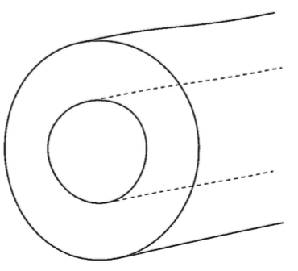
Arteries
Arteries are thick, elastic and muscular blood vessels that carry blood away from the heart. The muscular walls are pushed open by the blood being forced out of the heart. The arteries then narrow behind the blood, helping to push it along. They are always under high pressure because of the narrow space that the blood flows. Arteries are also where you can feel a pulse – this is the movement of blood being pushed out of the heart.
- Locate the pulse in your wrist using your three middle fingers of your other hand. You are feeling your wrist artery wall expanding! Count your pulse over the course of 30 seconds, then x2. How many times does your heart beat in a minute? ……………………………
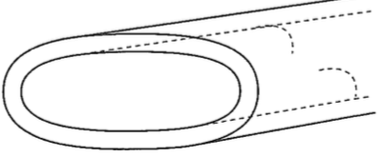
Arterioles are small arteries, which are branches of larger arteries that become capillaries.
Veins
Veins are thinner blood vessels that carry blood to the heart. They are not muscular, and don’t change shape. This makes the blood flow and pressure constant. The flow of blood is directed by valves that only let the blood flow towards the heart. Venules are small veins that are made up of re-joining capillaries, that form into veins.
Capillaries
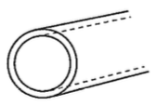
Capillaries are very small blood vessels that connect arteries to veins, and are very close to all cells in the body. They are only wide enough for one red blood cell to pass through at a time, and the walls are 1 cell thick. They allow gas exchange of materials between the blood and cells; e.g. carbon dioxide passes from cells into the capillaries, and oxygen also passes from the capillaries into the cells. These are what line the alveoli in the lungs, as well as lie close to the surface of our skin to give us a healthy pinky glow!
Remember the rule:
V.E.A.L

Veins Enter (the heart) Arteries Leave (the heart)
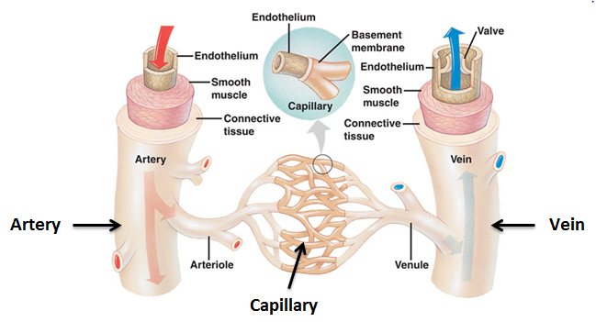
- Draw a cross-section of the structure of an artery and a vein in the space below.

Artery | Vein

- Describe the flow of blood through the blood vessels, referring to the diagram below:
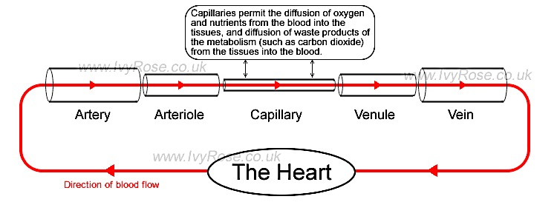
………………………………………………………………………………………………………………………………………………………………………………………………………………………………………………………………………..
………………………………………………………………………………………………………………………………………..………..……………………………………………………………………………………………………………………
Complete the table comparing and contrasting the three main types of blood vessels.

 | Arteries | Veins | Capillaries
Structure of walls
(thick/thin; amount of muscle; elasticity; size of lumen, etc.)
Diagram
Pressure in blood vessel (high/low)
Direction of blood flow
Valves (present/absent)
Pulse
(yes/no)
Questions

- Why is the wall structure an important feature of arteries?
………………………………………………………………………………………………………………………………………..………………………………………………………………………………………………………………………………………..…………………………………………………………………………………………
- Why are the thinner, less muscular and less elastic walls not a problem for veins?
………………………………………………………………………………………………………………………………………..………………………………………………………………………………………………………………………………………..…………………………………………………………………………………………
- Explain the role of valves in assisting the veins return blood back to the heart.
………………………………………………………………………………………………………………………………………..………………………………………………………………………………………………………………………………………..…………………………………………………………………………………………
- Thinking about the functional role of capillaries, why is having 1 cell walls thick important?
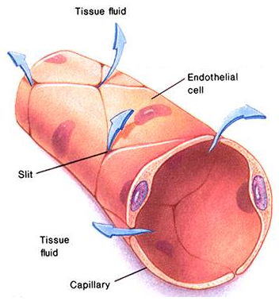
…………………………………………………………………………………………………….
……………………………………………………………………………………………………
……………………………………………………………………………………………………
……………………………………………………………………………………………………
……………………………………………………………………………………………………
…………………………………………………………………………………………………………………………

The Heart
Did you know?
The adult human heart beats 72 times a minute; 100,000 times a day; 3,600,000 times a year; and 2.5 billion times during a lifetime!
The heart is a hollow, muscular organ located between the lungs in the thoracic cavity. It is protected by the sternum and ribcage, and by the pericardium membrane that reduces friction and prevents the heart from overstretching. The heart is about 12cm long, 8cm wide, and 6cm from front to back. It’s roughly the same size as your fist! The average weight of a human heart is 250g – 300g.
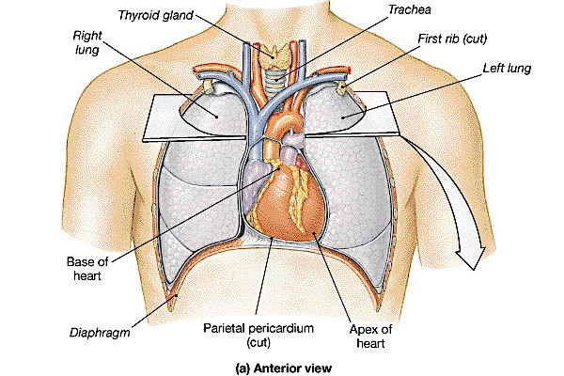
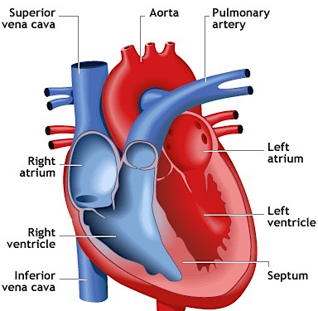
The heart is divided into four chambers. The right atrium, the right ventricle, the left atrium, and the left ventricle. The two sides of the heart are separated by the septum. All deoxygenated blood enters the right side of the heart through two veins: the superior vena cava and the inferior vena cava. When the right atrium contracts, the blood goes through the atrioventricular valve and into the right ventricle.

When the right ventricle contracts, blood is pumped through the pulmonary valve, into the pulmonary artery and into the lungs, where it picks up oxygen. It is now oxygenated blood.

Blood returns to the heart from the lungs through the pulmonary vein and goes into the left atrium. When the left atrium contracts, blood travels through the atrioventricular valve and into the left ventricle.
The left ventricle pumps blood through the aortic valve and into the aorta. All valves are one-way to prevent blood from flowing backwards, and only open when each chamber contracts. The aorta is the main artery of the body. It receives all the oxygenated blood that the heart has pumped out, and distributes it to the rest of the body.
The heart contracts in two stages. Firstly, the right and left atria contract at the same time, pumping blood to the right and left ventricles. Then, the ventricles contract together to push blood out of the heart. This is why it is referred to as a “double pump. Finally, the heart muscle relaxes, allowing it to fill with blood before the next heartbeat.
In the diagram below, label the chambers, arteries, and veins you see. Colour all number 1s blue and number 2s red to demonstrate that blood flows into and out of the heart at the same time. If a number is not in a heart chamber, this means that the blood has left that chamber.
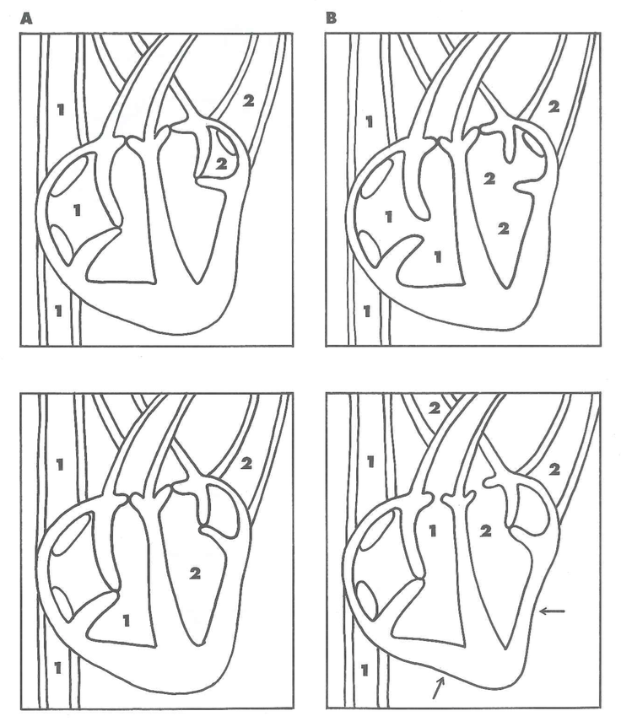

What did you observe in the diagram above about the movement of blood in the heart?
……………………………………………………………..…………………………………..………………………….………………………………….……………………………………………………………..……………..………………………………………………..………………………….………………………………….……………………………………………………………..…………………………………..………………………….…………………………………………..…………………………..………………………….

Explain why the heart is sometimes referred to as a “double pump”.
……………………………………………………………..…………………………………..………………………….………………………………….……………………………………………………………..…………………………………..………………………….………………………………..…………………………..…………………………..…………………………..…………………………

- Complete the following activity on HEART RATE:

Two people had the change in their heart rate recorded during exercise. Mary trained on a regular basis and was reasonably fit. Ella did not train at all. The results are shown below.
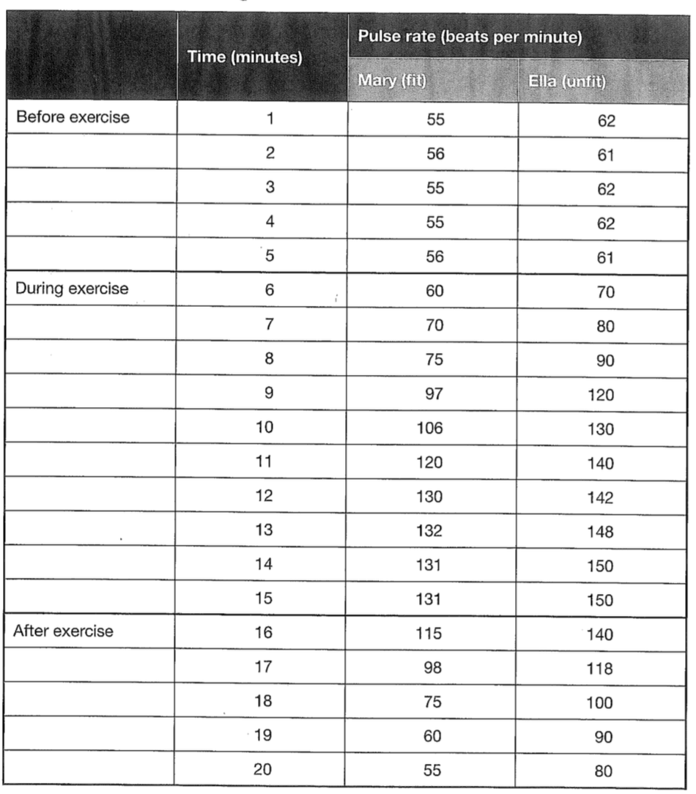
Briefly describe how the pulse rates for Mary and Ella changed during exercise.
……………………………………………………………..…………………………………..………………………….……………………………..……………………………………………………………..…………………………………..………………………….………………………………………………………………………………………………………………………………………………………

Construct line graphs of this data using the set of axes provided.

Title: _______________________________________________________

Propose why these changes in pulse rates occurred.
……………………………………………………………..…………………………………..………………………….……………………………..……………………………………………………………..…………………………………..………………………….……………………………..……………………………………………………………..…………………………………..………………………….………………………………………………………………………………………………………………………………………

Compare the changes in pulse rate and account for the differences between the girls:
- Before exercise
……………………………………………..…………………………………..………………………….……………………………..……………………………………………..…………………………………..………………………….……………………………..……………………………………………………………………………………………………………………

- In the first 5 min of exercise
……………………………………………..…………………………………..………………………….……………………………..……………………………………………..…………………………………..………………………….……………………………..……………………………………………………………………………………………………………………

- In the second 5 min of exercise
……………………………………………..…………………………………..………………………….……………………………..……………………………………………..…………………………………..………………………….……………………………..……………………………………………………………………………………………………………………
- After the exercise was completed
……………………………………………..…………………………………..………………………….……………………………..……………………………………………..…………………………………..………………………….……………………………..……………………………………………………………………………………………………………………

